COMPARATIVE IMPURITY PROFILES STUDY OF IBUPROFEN TABLETS BETWEEN UNDERLISENCE LOCALLY MANUFACTURED PRODUCTS AND THOSE MANUFACTURED FROM ORIGINAL COMPANY
H. Zehlawi*¹
¹*Department of Pharmaceutical Chemistry and Drug Control, Faculty of Pharmacy, Damascus University, Mazzeh Street, Damascus, Syrian Arab Republic.

ABSTRACT
Underlisence drugs are pharmaceutical products manufactured by companies that bought the active ingredient and rights from the original company to produce identical products that have same trade names and properties, dissolution, disintegration, uniformity of content, amount of API's, stability, bioavailability and impurity profiling. Therefore they are more expensive than other generics produced in the same country. This study shows that there is symmetry between impurity profiles of underlisence and original drugs. British Pharmacopoeia method has been applied by using HPLC-UV. This study shows the importance of impurity profiling not only for API's but also for the finished product to assure safety of the drug treatment.

KEYWORDS
Impurity profiling, Ibuprofen tablets, Underlisence drugs and British Pharmacopoeia.

Author for Correspondence:
Hala Zehlawi H,
Department of Pharmaceutical Chemistry and Drug Control,
Faculty of Pharmacy, Damascus University,
Mazzeh Street, Damascus, Syrian Arab Republic.
Email: halajoud@yahoo.com

INTRODUCTION
Non-steroidal anti-inflammatory drugs (NSAIDs), are a class of drugs that provides analgesic (pain-killing) and antipyretic (fever-reducing) effects, and, in higher doses, anti-inflammatory effects¹. NSAIDs are the most common pain relief medicines in the world. Every day more than 30 million Americans use them to reduce symptoms of headaches, sprains, arthritis, and other daily discomforts, according to the American Gastroenterological Association. In addition to lowering fever and reduce swelling². Ibuprofen is one of NSAIDs its chemical structure is shown in Figure No.1.
We find impurity test of ibuprofen tablets in British Pharmacopoeia (BP) and it is called related substances³. Ibuprofen has many impurities: A, B, C, D, E, F, G, H, I, J, K, L, M, N, O, P, Q, R. The main impurity is Ibuprofen impurity B: 2-(4-butylphenyl) propionic acid is considered a degradation product⁴, and it has adverse effects on CNS and dermal adsorption⁵. Its chemical structure is shown in Figure No.2.
Many studies have applied on ibuprofen and its impurities alone⁵⁻⁷ or combined with other compounds⁸ using chromatographic methods, electrophoresis-MS⁹ electro-chromatography¹⁰, and tandem column liquid chromatography¹¹.

MATERIALS AND METHOD
Reagents and chemicals
Reference standard of ibuprofen have been used from Sigma Aldrich, China. Ibuprofen impurity B have been bought from British Pharmacopoeia Commission Laboratory, England. Tablets of ibuprofen have been tested from Abott, USA and the underlisence tablets by Abott locally manufactured 400 mg and 600 mg, and tablets from GSK manufactured undelisence in Egypt, and the underlisence tablets by GSK locally manufactured 400 mg, tablet samples named I1, and its peer I2, I3, and its peer I4, I5, and its peer I6 randomly.
HPLC grade methanol and acetonitrile by Panreac Spain. Ortho phosphoric acid by BDH, England. HPLC grade water by Chem Lab, Belgium, have been used for analysis.
Chromatographic conditions
Jasco PU apparatus by Japan have been used to achieve study, equipped with pump and degasser Jasco PU-980, UV/Vis detector Jasco PU-970, injector with 20 μl loop and C18 stainless steel column (4.6 x 150) mm end capped with octadecylsilyl silica gel 5 μ (spherisorb ODS₂). In addition to electronic balance, microliter syringe, pipettes, ultrasonic apparatus, micropore filters.
The detection wavelength: 214 nm, injection volume: 20 μl, the mobile phase composed of (0,5 volume of orthophosphoric acid +340 volumes of acetonitrile +600 volumes of water diluted to 1000 volumes with water after equilibration), pumped at a flow rate of 2 ml / min. the mobile phase was filtered through 0.45 μ pore size filter and degassed ultrasonically after mixing. The run time was set at 30 minute with the HPLC system operating at room temperature.
Preparation of solutions
Sample solution (1):10 tablets have weighed and the average weight was calculated, and then crushed, mixed thoroughly and quantity of powdered tablets have been taken containing 0.2 g of ibuprofen and transferred to a 100 ml volumetric flask, 30 ml of methanol was added and mixed for 30 minutes using a sonicator, then 30 ml methanol was added and sufficient water to produce 100 ml, the solution have been mixed well then filtered through a glass microfiber filter paper. Sample solution (2):1 volume of solution (1) was taken and diluted to 100 volumes with the mobile phase.
Sample solution
(1) and (2) have been prepared for each one of the six tablets samples.
Standard solution
50 mg of ibuprofen reference standard was added to 2.5 volume of ibuprofen impurity B solution prepared by taking (1 volume of ibuprofen impurity B and diluting it to 10 volumes with methanol) then methanol was added to produce 25 ml.

METHODOLOGY
Equilibrate the column with the mobile phase for 45 minutes before analysis.
The chromatographic system used for analysis must pass the system suitability limits before sample analysis can commence. Injection repeatability (Figure No.3) and RSD of it, tailing factor (T), theoretical plate number (N), and resolution (Rs) for the principal peak, and its degradation product were the parameters tested on standard solution.
In solution (3) the height of Ibuprofen impurity a should be more than 1.5 times of the lowest point of the curve b.
Acceptance limits
The product was considered accepted when, in the chromatogram obtained with solution (1).
The peak area corresponding to ibuprofen impurity B is not greater than the area of ibuprofen impurity B in the chromatogram obtained with solution (3) (0.3%).
The peak area of any other secondary peak is not greater than 0.3 times the area of ibuprofen peak in the chromatogram obtained with solution (2) (0.3%).
sum of peak areas of any secondary peak is not greater than 0.7 times the area of ibuprofen peak in the chromatogram obtained with solution (2) (0.7%).
Disregard any peak with area less than 0.1 times the area of ibuprofen peak in the chromatogram obtained with solution (2) (0.1%) (Figure No.4-9).

RESULTS AND DISCUSSION
System suitability test (SST)
Six repeated injections of standard solution Figure No.3 have been made and the RSD was:
0.15 for ibuprofen accepted <2
1.95 for impurity B accepted <2
Resolution = 2.60 ± 0.02 >1.5 accepted
Tailing factor = 1.46 ± 0.01 >2 accepted
Number of theoretical plates = 10784.67 ± 56.22 >2000 accepted.

Table No.1: Results of Ibuprofen tablets I1 solution (1) and (2)
S.No | I1 | Peak name | Retention time | Peak area | Percentage
1 | Solution (1) | Ibuprofen | 20.25 | 31520170 | 100%
2 | Solution (2) | Ibuprofen | 20.79 | 347952 | 1%

Table No.2: Results of Ibuprofen tablets I2 solution (1) and (2)
S.No | I2 | Peak name | Retention time | Peak area | Percentage
1 | Solution (1) | Ibuprofen | 20.63 | 31156256 | 100%
2 | Solution (2) | Ibuprofen | 20.81 | 313650 | 1%

Table No.3: Results of Ibuprofen tablets I3 solution (1) and (2)
S.No | I3 | Peak name | Retention time | Peak area | Percentage
1 | Solution (1) | Ibuprofen | 20.63 | 31091722 | 100%
2 | Solution (2) | Ibuprofen | 20.81 | 303589 | 1%

Table No.4: Results of Ibuprofen tablets I4 solution (1) and (2)
S.No | I4 | Peak name | Retention time | Peak area | Percentage
1 | Solution (1) | Ibuprofen | 20.63 | 30726421 | 100%
2 | Solution (2) | Ibuprofen | 20.81 | 325667 | 1%

Table No.5: Results of Ibuprofen tablets I5 solution (1) and (2)
S.No | I5 | Peak name | Retention time | Peak area | Percentage
1 | Solution (1) | Ibuprofen | 20.90 | 32064421 | 100%
2 | Solution (2) | Ibuprofen | 20.81 | 335709 | 1%

Table No. 6: Results of Ibuprofen tablets I6 solution (1) and (2)
S.No | I6 | Peak name | Retention time | Peak area | Percentage
1 | Solution (1) | Ibuprofen | 20.87 | 31576008 | 100%
2 | Solution (2) | Ibuprofen | 20.81 | 328137 | 1%

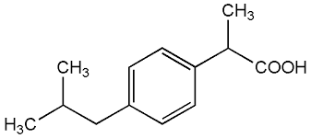
Figure No.1: Chemical structure of Ibuprofen
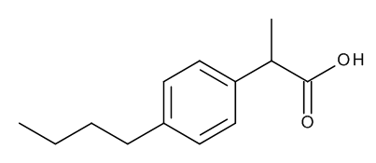
Figure No.2: Chemical structure of ibuprofen impurity B
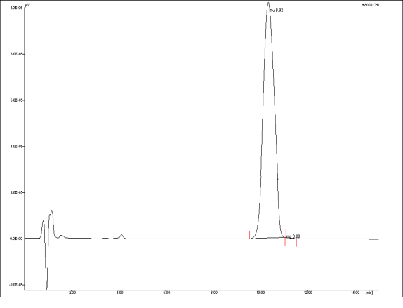
Figure No.3: Standard solution injection for SST
Ibuprofen tablets I1 solution 1 and 2 have been tested and the results appear in Figure No.4 and Table No.1.
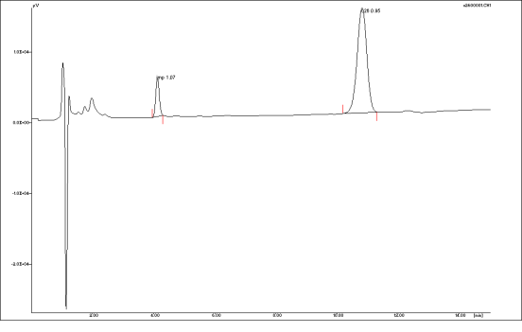

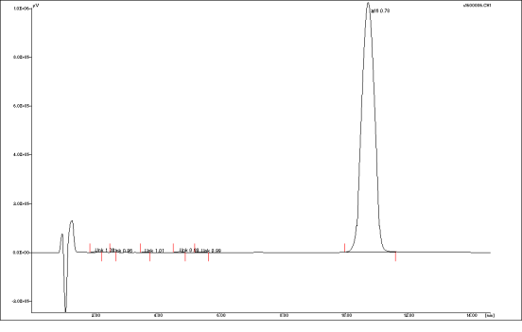
Figure No.4: Ibuprofen tablets I1 solution (1) and (2)

Ibuprofen tablets I2 solution 1 and 2 have been tested and the results appear in Figure No.5 and Table No.2.
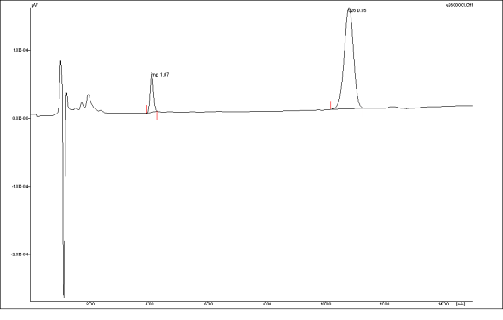

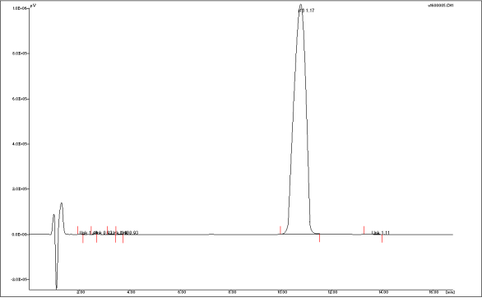
Figure No.5: Ibuprofen tablets I2 solution (1) and (2)
Ibuprofen tablets I3 solution 1 and 2 have been tested and the results appear in Figure No.6 and Table No.3:
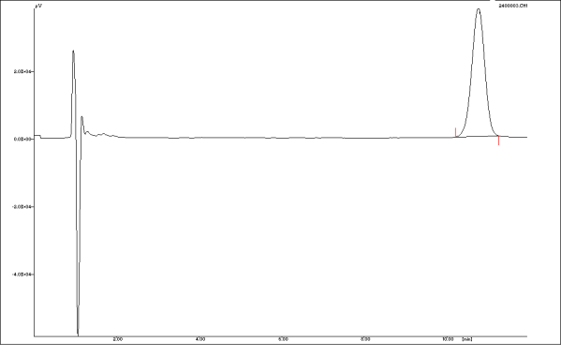
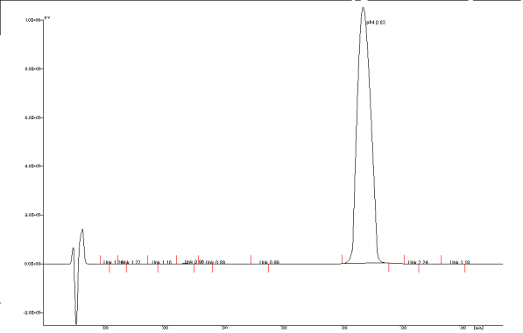
Figure No.6: Ibuprofen tablets I3 solution (1) and (2)
Ibuprofen tablets I4 solution 1 and 2 have been tested and the results appear in Figure No.7 and Table No.4.
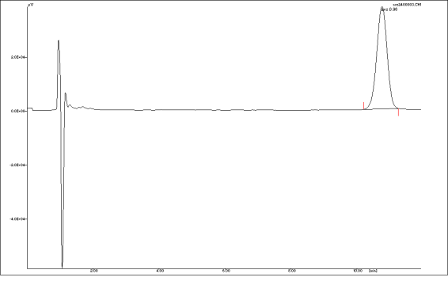

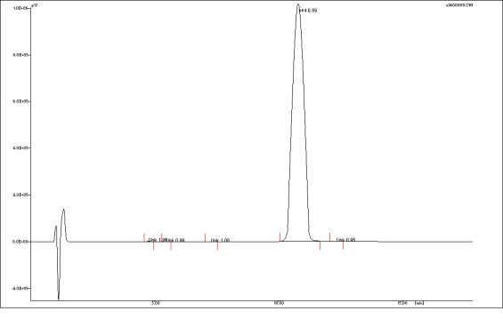
Figure No.7: Ibuprofen tablets I4 solution (1) and (2)
Ibuprofen tablets I5 solution 1 and 2 have been tested and the results appear in Figure No.8 and Table No.5.
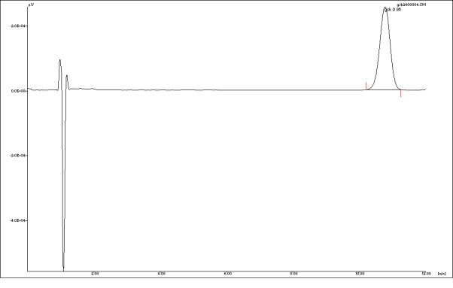

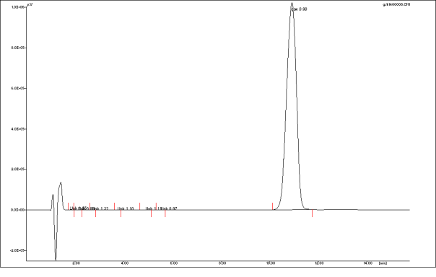
Figure No.8: Ibuprofen tablets I5 solution (1) and (2)
Ibuprofen tablets I6 solution 1 and 2 have been tested and the results appear in Figure No.9 and Table No.6:
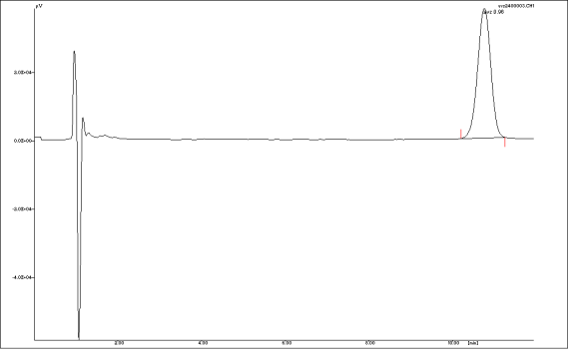
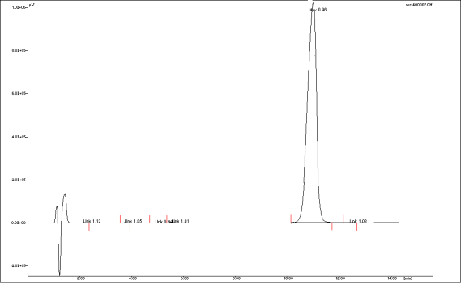
Figure No.9: Ibuprofen tablets I6 solution (1) and (2)
All Ibuprofen tablets products I1, I2, I3, I4, I5, and I6 have successfully achieved pharmacopoeial limits and all impurities were within limits.

CONCLUSION
Impurity profile test was applied on under-lisenced products and compared with their peers. Compatibility was achieved between the product locally manufactured and its peer. All impurities were within pharmacopeial limits. System suitability test was applied and its statistical analysis values were accepted.

ACKNOWLEDGEMENT
I’m very thankful to Department of pharmaceutical chemistry and drug control, Faculty of pharmacy, Damascus University, Damascus, Syrian Arab Republic, I would also like to thank the Management, for providing the necessary facilities to carry out this work.

CONFLICT OF INTEREST
We declare that we have no conflict of interest.

BIBLIOGRAPHY
- Wikipedia, Nonsteroidal anti-inflammatory drug, available from, https://en.wikipedia.org/wiki/Nonsteroidal_anti-inflammatory_drug, Accessed on 19 Aug. 2015.
- Morgan Griffin R. Pain Relief, How NSAIDs Work, webmd.com, Arthritis Health Center, available from, http://www.webmd.com/arthritis/features/pain-relief-how-nsaids-work, [Accessed on 19 Aug. 2015].
- British Pharmacopoeia 2009.
- Kumar R, Singla R. Impurities in Pharmaceutical Dosage Form, A Subject Matter of Great Concern, Webmed central.com, Published on, 3(4), 17 Jan 2012.
- Gasco-Lopez A I, Izquierdo-Hornillos R, Jimenez A. LC method development for ibuprophen and validation in different pharmaceuticals, J. Pharm.Biomed, Anal, 21(1), 1999, 143-149.
- Kucera R, Sochor J, Klimes J, Dohnal J. Use of the zirconia-based stationary phase for separation of ibuprofen and its impurities, Journal of Pharmaceutical and Biomedical Analysis, 38(4), 2005, 609-618.
- Asmus P A. Determination of 2-(4-isobutylphenyl) propionic acid in bulk drug and compressed tablets by reversed-phase high-performance liquid chromatography, Journal of Chromatography-A, 331(1), 1985, 169-176.
- Gnana Raja M, Geetha G, Sangaranarayanan A. Simultaneous, Stability Indicating Method Development and Validation for Related Compounds of Ibuprofen and Paracetamol Tablets by RP-HPLC Method, Journal of Chromatography Separation Techniques, 3(8), 2012, 1-5.
- Stubberud K, Callmer K, Westerlund D. Partial filling-micellar electrokinetic chromatography optimization studies of ibuprofen, codeine and degradation products, and coupling to mass spectrometry, Part II, Electrophoresis, 24(6), 2003, 1008-15.
- Quaglia M G, Donati E, Fanali S, Catarcini P. Ibuprofen quality control by electro chromatography, Farmaco, 58(9), 2003, 699-705.
- Huidobro A, Ruperez F, Barbas C. Tandem column for the simultaneous determination of arginine, ibuprofen and related impurities by liquid chromatography, Journal of chromatography-A, 1119(1-2), 2006, 238-45.

